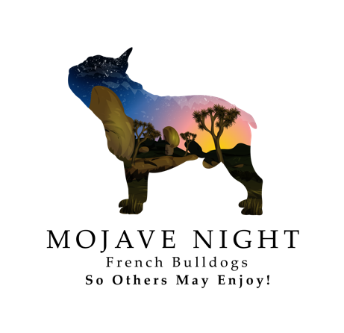

**Health Guarantee**

To the best of my knowledge this puppy is free from any health defects at time of sale and is the best pet

quality available. I have done everything possible to produce healthy, sound puppies and by raising the puppies

in the best way possible in regards to diet, exercise, socialization and veterinarian care. All necessary

vaccinations and deworming for the puppy's age have been given, and a record of this vaccination history is

supplied to buyer at time of Sale. All expenses incurred after the puppy leaves the Seller, medical or otherwise,

are the responsibility of the Buyer. By reading and signing this document, both Seller and Buyer enter into this

agreement in the purchase of identified/named puppy. The buyer agrees to maintain the puppy's health in good

condition, and to provide yearly examinations, vaccinations, and any other customary procedures necessary to

assure good health.

**General Health Guarantee:**

Buyer is given 72 hours from purchase date to have puppy examined by a licensed veterinarian. If buyer

chooses not to have puppy examined by a licensed veterinarian within 72 hours of purchase date, then this

health guarantee/contract will become null and void. If any life-threatening condition is found at first vet visit,

then buyer can return puppy to seller for full refund of purchase price. Seller must be informed immediately of

the examination results by phone call. Buyer must also immediately (within 24 hours) bring puppy back to

breeder with written report of vet findings. The failure of this will result in the cancellation of this guarantee.

This health guarantee does not cover worms, fleas, parasites, ear mites, kennel Cough, Hypoglycemia, Giardia,

or Coccidiosis.

(These conditions are very easily treated by a licensed veterinarian) Vet bills, medications, and any other

medical expenses will be paid by the buyer. Seller will not be responsible for any vet bills or any other

expenses incurred by buyer.

**Genetic Health Guarantee:**

The Seller guarantees the puppy for one year from the date of birth against life threatening congenital or

hereditary defects. If the puppy has a life threatening congenital or hereditary defect that has been diagnosed

by 2 unassociated licensed veterinarians that warrants euthanasia or will require continuous/serious medical

treatment throughout the course of the puppy's life; the Seller will provide the Buyer with a new puppy with

similar traits (upon availability) after the Buyer returns said puppy back to the seller with all original

registration paperwork. All papers must be signed with a transfer to the Seller. No cash refunds will be given.

Please note that many disorders that would be major problems in other breeds may not be considered

hereditary.

The Seller is not responsible for miscellaneous problems such as: hip dysplasia, hypoglycemia, Coccidiosis,

Giardia, parasites, types of bacterial infections, bad or uneven bites, inguinal or umbilical hernias, or certain

disorders that may because by environmental factors, i.e.: allergies, thyroid dysfunction, mange, ear mites, skin

allergies, demedex, fleas, ticks, kennel cough and other autoimmune disorders which are usually caused by

bacteria. Elongated soft palates, small or collapsed nostrils, open fontanel, Cherry Eyes, Loose Hips, loose

knees, and skin allergies are considered normal in the breed and are not covered by this guarantee. Hernia

repairs or cherry eyes do not warrant return of money as it is not life threatening and doesn't interfere with

quality of life of puppy. If the puppy in your care has been treated for any injury the contract is null and void.

There is no guarantee by the Seller of breeding abilities, show quality, size, coat quality, temperament, or

adaptability. I do not guarantee size or testicles on males. There is no guarantee of warranty that the buyer will

be able to show or breed the puppy, regardless of show or breeding potential. There is no refund or

replacement puppy given if you the buyer decide the said puppy is not to your liking.

No replacement puppy will be given if the puppy has been bred, spayed, neutered, or euthanized without

permission of the breeder/seller.

A returned puppy must be returned to the seller in good condition, other than the specified problem, at the

expense of the buyer. The owner will then qualify for a replacement puppy.

Buyer understands that the replacement puppy may not be from the exact same parents of original puppy.

Buyer is responsible for transportation costs to and from the Seller on a replacement puppy.

The Seller neither makes or implies any warranties or guarantees, expresses or implied, other than those

Written in the agreement. This document constitutes the entire agreement between the Seller and buyer with

respect to this sale.

Buyer is agreeing to purchase a **PET ONLY** with a spay/neuter contract. Buyer agrees to spay/neuter their puppy, by one (1) year of age. The puppies’ **Spay/Neuter** documentation/certification must be sent to us, verifying the procedure. Please provide proof within 14 days of the procedure, email a copy to [mojavenight.fb@gmail.com](mailto:mojavenight.fb@gmail.com). In purchasing a puppy from us, buyer agrees to enter a spay/neuter contract agreement.

**This puppy is NEVER to produce a litter without the written permission of the BREEDER.** In the event that the BUYER breeds, attempt to breed, or accidentally breeds, the dog/bitch, the BREEDER has the right of immediate possession of the dog/bitch, including all papers, without any reimbursement and the BUYER would owe the BREEDER liquidation damages of $2,500 per puppy born of breach of this contract. Every puppy that resulted from such a breeding would then become the sole property of the BREEDER and must be delivered immediately to the BREEDER at the BUYER'S expense with the dog/bitch.

**BREEDER holds all breeding rights on said dog to ensure the BREEDER'S bloodlines/program are not compromised.** If this dog/bitch is bred without signed written consent, full ownership is reverted back to the BREEDER. The dog/bitch is to be returned intact within 7 days to the BREEDER'S current residence.

Date of Contract and Bill of Sale: __________________________________

Price: _________________ Payment Form: _______________________________

Dog Information:

Breed: FRENCH BULLDOG

Sex: __________________

DOB: _________________

AKC Litter Registration: _________________

Seller Information:

Linnell & Hope Evans

(336) 609-1220,

(760) 808-6739,

Mojavenight.fb@gmail.com

Buyer Information:

Name: __________________________________________________________

Address: ________________________________________________________

Phone: __________________________________________________________

Email: __________________________________________________________

I the Buyer have read, received, and understand and agree to the terms of this contract/guarantee and

conditions of sale and accept full responsibility for the health and well-being of the purchased puppy as set

forth by my hand.

_________________________________________________________________________________

Buyer Date

_________________________________________________________________________________

Seller Date